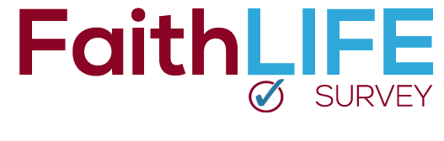

The survey begins today!

For the next three weeks, our church will participate in the FaithLIFE Survey and your opinion is very important. This survey will provide valuable information about the faith practices and beliefs of our congregation, and how we can best help you live out your faith in all of life.

Taking the survey is very easy. Simply go to faithlife.me and click on the “Take Survey” link. Be sure to use our church code:

faithlife.me

<INSERT CHURCH NAME>

**code**